Google Assistant Control-

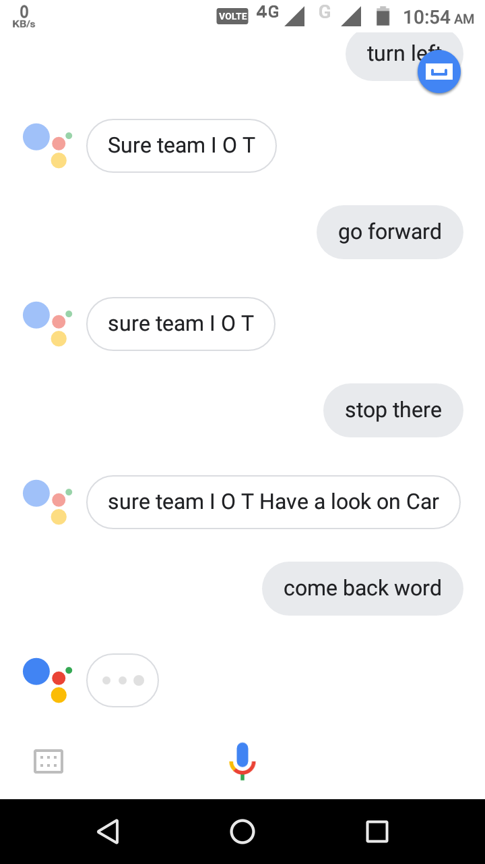

Fig No.9